Provide insights for targeted marketing campaigns.

Demographic Targeting
- Age and Gender: The 26-35 age group spends the highest total amount, with a strong preference towards male customers (M) in this group. The 36-45 group is the second highest. Campaigns should heavily target males aged 26-45. * Geographic Focus: Uttar Pradesh and Maharashtra contribute significantly more to the total amount spent than any other state. Campaigns should prioritize these two states for maximum reach and return.

Product and Occupation Targeting
- High-Value Occupations (Sum of Amount): Customers in the IT Sector, Healthcare, and Aviation occupations are responsible for the highest total amount spent, indicating they have high purchasing power.
- Most Active Occupations (Measure): The occupations with the highest measure (which likely represents average transaction or frequency, though the exact definition is unclear) are Chemical, Govt, Media, and Automobile.
  - Targeting Strategy: Focus marketing for high-cost or luxury items on the IT Sector, Healthcare, and Aviation. Use broad-reach campaigns for fast-moving consumer goods (FMCG) or frequent purchase items on the Chemical and Govt sectors.
- Top Product Categories (Sum of Amount and Orders):
  - Clothing & Apparel and Food dominate both the total Sum of Amount and the Sum of Orders. This means these are the most popular and highest-grossing categories.
  - Electronics & Gadgets is the third highest in Sum of Amount, suggesting high-value individual purchases, while Footwear & Shoes is the third highest in Sum of Orders, indicating high purchase frequency.
Targeting Strategy: Run frequent promotions for Clothing & Apparel and Food. For Electronics, target the high-spending demographics (M, 26-45, IT/Healthcare) during peak sales periods.

POWERBI and PYTHON:

1)
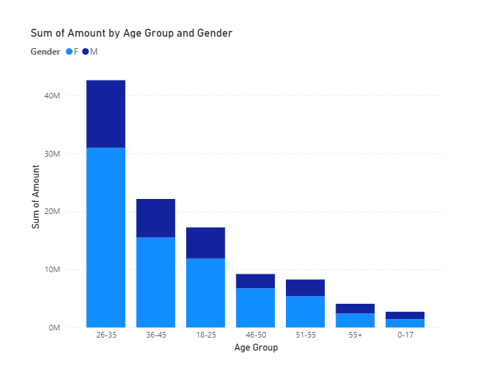
PYTHON CODE:

#question 1
import pandas as pd
data = pd.read_csv("Diwali Sales Data.csv", encoding='latin1')
print(data.describe())

age_group_sales = data.groupby('Age Group')['Amount'].sum()
max_age_group = age_group_sales.idxmax()
max_age_group_amount = age_group_sales.max()

gender_sales = data.groupby('Gender')['Amount'].sum()
max_gender = gender_sales.idxmax()
max_gender_amount = gender_sales.max()

print("the expected results (by Sales Amount):")
print("Max Contributing Age Group:", max_age_group)
print("Total Sales Amount by Max Age Group:", max_age_group_amount)
print("Max Contributing Gender:", max_gender)
print("Total Sales Amount by Max Gender:", max_gender_amount)

Output:

User_ID Age Marital_Status Orders Amount \
count 1.125100e+04 11251.000000 11251.000000 11251.000000 11239.000000
mean 1.003004e+06 35.421207 0.420318 2.489290 9453.610858
std 1.716125e+03 12.754122 0.493632 1.115047 5222.355869
min 1.000001e+06 12.000000 0.000000 1.000000 188.000000
25% 1.001492e+06 27.000000 0.000000 1.500000 5443.000000
50% 1.003065e+06 33.000000 0.000000 2.000000 8109.000000
75% 1.004430e+06 43.000000 1.000000 3.000000 12675.000000
max 1.006040e+06 92.000000 1.000000 4.000000 23952.000000

Status unnamed1
count 0.0 0.0
mean NaN NaN
std NaN NaN
min NaN NaN
25% NaN NaN
50% NaN NaN
75% NaN NaN
max NaN NaN
the expected results (by Sales Amount):
Max Contributing Age Group: 26-35
Total Sales Amount by Max Age Group: 42613443.94
Max Contributing Gender: F
Total Sales Amount by Max Gender: 74335856.43

2) 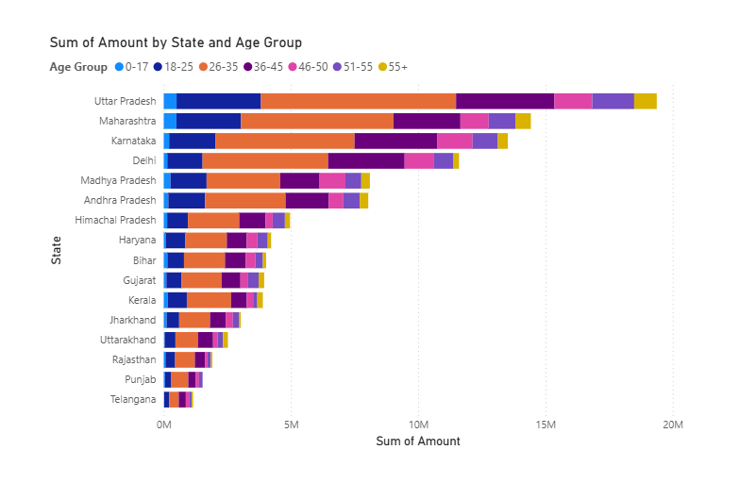
PYTHON CODE:

#question 2
states=data.groupby('State')['Amount'].sum()
zonal=data.groupby('Zone')['Amount'].sum()
print("the expected results:")
print("the zone which has received maximum sales amount:",zonal.idxmax())
print("corresponding values:",zonal.max())
print("the state which has received maximum sales amount:",states.idxmax())
print("corresponding sales amount value:",states.max())

OUTPUT:

the expected results:
the zone which has received maximum sales amount: Central
corresponding values: 41600873.45
the state which has received maximum sales amount: Uttar Pradesh
corresponding sales amount value: 19374968.0

3) 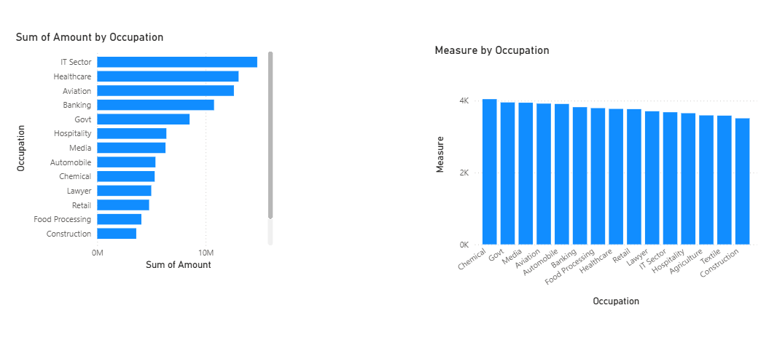
PYTHON CODE:

#question 3
occupational_max=data.groupby('Occupation')['Orders'].sum()
print("the expected results:")
print("Occupation which has received maximum number of orders:",occupational_max.idxmax())
print("Corresponding order values:",occupational_max.max())

OUTPUT:

the expected results:
Occupation which has received maximum number of orders: IT Sector
Corresponding order values: 4010

4)

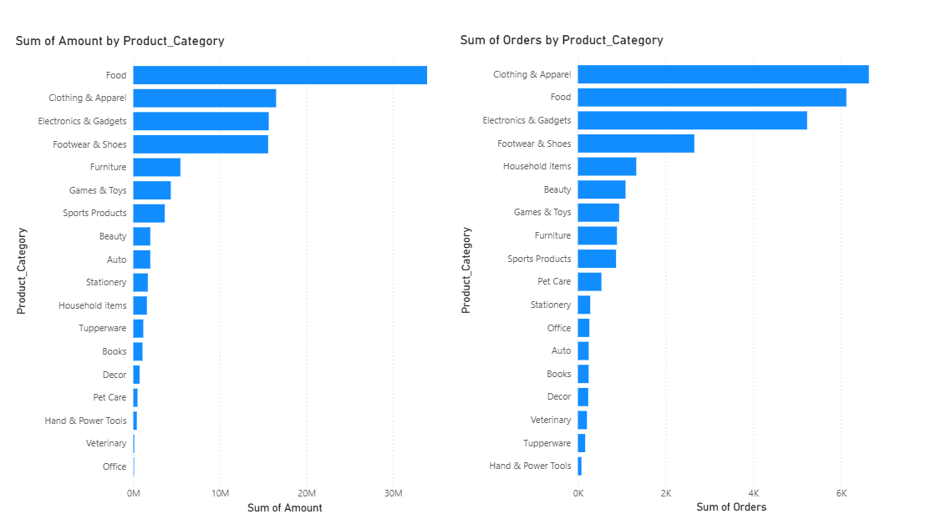

PYTHON CODE:

#question 4
pro_cat=data.groupby('Product_Category')['Amount'].sum()
print("the expected results:")
print("product category which earned maximum amount:",pro_cat.idxmax())
print("corresponding values is:",pro_cat.max())

OUTPUT:

the expected results:
product category which earned maximum amount: Food
corresponding values is: 33933883.5

5)
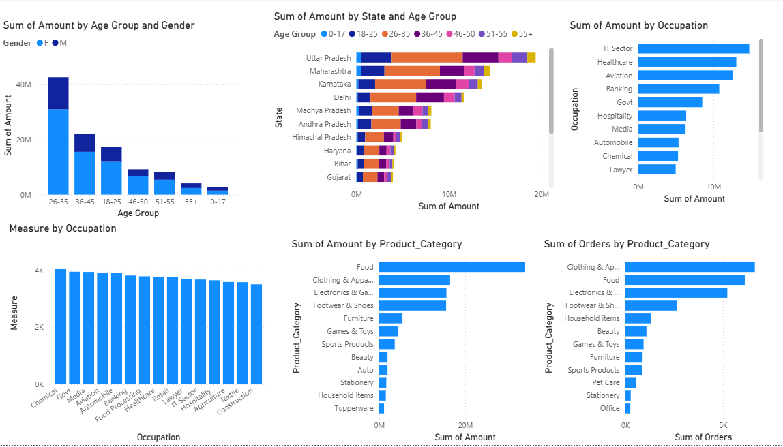

PYTHON CODE:

#question 5
mart_status=data.groupby("Marital_Status")["Amount"].sum()
mart_status1=data.groupby("Marital_Status")["Orders"].sum()
print("the expected results:")
print("Marital status with maximum sales(0-single, 1-married):",mart_status.idxmax())
print("Corresponding values:",mart_status.max())
print("Marital status with maximum orders:",mart_status1.idxmax())
print("Corresponding values:",mart_status1.max())
#grouping by orders for product category,age groups, state/zone(question 5 contd)
pro_cat_orders=data.groupby('Product_Category')['Orders'].sum()
states1=data.groupby('State')['Orders'].sum()
zonal1=data.groupby('Zone')['Orders'].sum()
age_group_sales1 = data.groupby('Age Group')['Orders'].sum()
max_age_group1 = age_group_sales1.idxmax()
max_age_group_ord = age_group_sales1.max()
gender_sales1 = data.groupby('Gender')['Orders'].sum()
max_gender1 = gender_sales1.idxmax()
max_gender_ord = gender_sales1.max()
print("the expected results:")
print("Product category with max. orders:",pro_cat_orders.idxmax())
print("Corresponding order value:",pro_cat_orders.max())
print("Zone which covers max. Orders:",zonal1.idxmax())
print("Corresponding value is:",zonal1.max())
print("State which covers max. Orders:",states1.idxmax())
print("Corresponding values:",states1.max())
print("Age Group places the maximum Orders:",max_age_group1)
print("Corresponding values:",max_age_group_ord)
print("Gender which places maximum orders:",max_gender1)
print("Corresponding values are:",max_gender_ord)

OUTPUT:

the expected results:
Marital status with maximum sales(0-single, 1-married): 0
Corresponding values: 62125386.44
Marital status with maximum orders: 0
Corresponding values: 16258
Product category with max. orders: Clothing & Apparel
Corresponding order value: 6634
Zone which covers max. Orders: Central
Corresponding value is: 10640
State which covers max. Orders: Uttar Pradesh
Corresponding values: 4813
Age Group places the maximum Orders: 26-35
Corresponding values: 11398
Gender which places maximum orders: F
Corresponding values are: 19568

